Simulink to C

**Task Goal: Run our control model (*Control Law*) from our main python script.**

**Problem:** How to interface between the two languages (MATLAB vs python).

**Approach**: Convert Simulink model to C++ via Simulink Coder app. Create a python wrapper to execute this C code model.

**Breaking down this task**:

* First, generate C++ from a simplified Simulink model.
* Second, run the C++ code from a C++ console application. Make sure the ability to read/write output/input is retained.
* Third, create and run a python wrapper to execute the same C++ code. Make sure IO capabilities are retained.
* Fourth, repeat the above with the actual model and test.

**Generating C++ Code from Simulink Model**

Simulink Coder App must be installed to MATLAB. The screenshot below shows where you can access this.

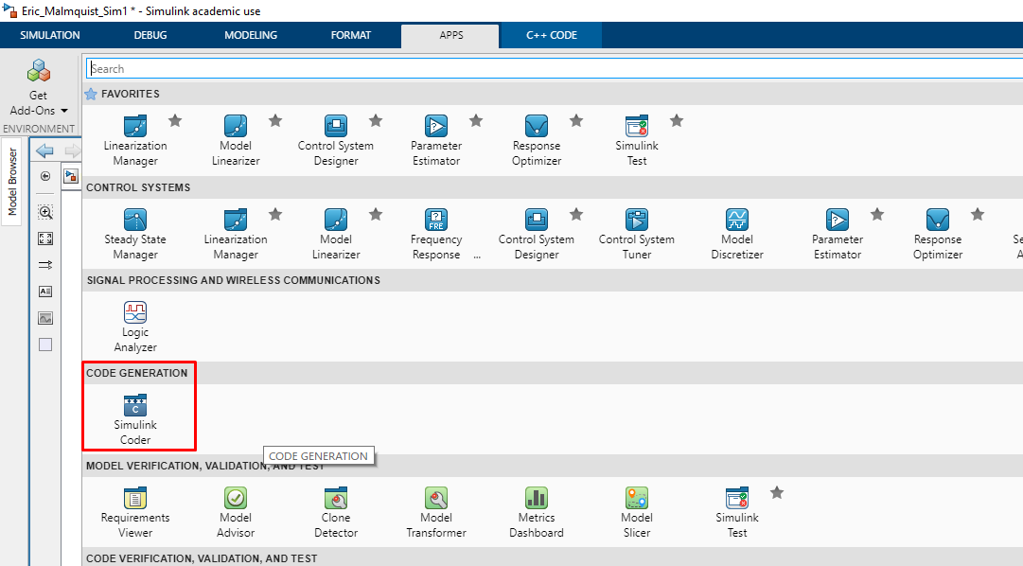

The Simulink Coder taskbar looks like this:  
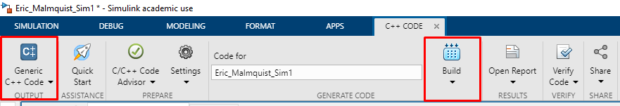

Under OUTPUT, we can select C++ code instead of C code. For now, we are using C++. If C code offers any exceptional benefits, we may use that instead.

Under GENERATE CODE can select **Generate Code Only**